



Data Structures & Algorithm
LAB MANUAL

Disclaimer: The content is curated from online/offline resources and used for educational purpose only
Implement a Linear Queue

Objective:
To implement basic queue operations (enqueue and dequeue) using Python list.

Equipment Required:
- Computer with Python installed, text editor/IDE.

Prerequisites:
- Understanding of queue data structure, Python lists, and indexing.
Problem Statement:
Create a linear queue using a list and implement enqueue and dequeue operations.

Procedure:
- Use a list to represent the queue.
- Enqueue elements using append().
- Dequeue elements using pop(0).
- Print the queue after each operation.

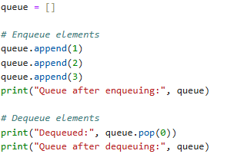
Output:
